University of Texas Rio Grande Valley

DroneBlocks Report

Drexel Lagare, Robert Escobedo

CMPE-4371-01

Dr. Tomai & Dr .Hongkai Yu

9/23/2019

DroneBlocks application is a drag and drop block programming environment that is available as a plugin for Chrome or an app for Android & IOS that works with drones like the Phantom 3, Phantom 4, Mavic Pro, Mavic Air, Spark, and Tello. DroneBlocks has an easy to use interface with all the basic commands for your drone on the left-hand side on Figure 1. On the right-hand side, clicking on the three blue lines will give you a side menu that has: Login, New Mission, Launch Mission Show Mission Code, Switch Metric Units and DJI Blocks on Figure 2.

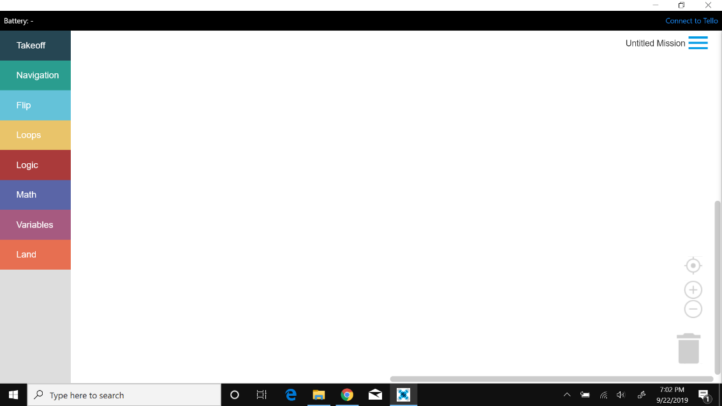

Figure 1: DroneBlocks Command Menu

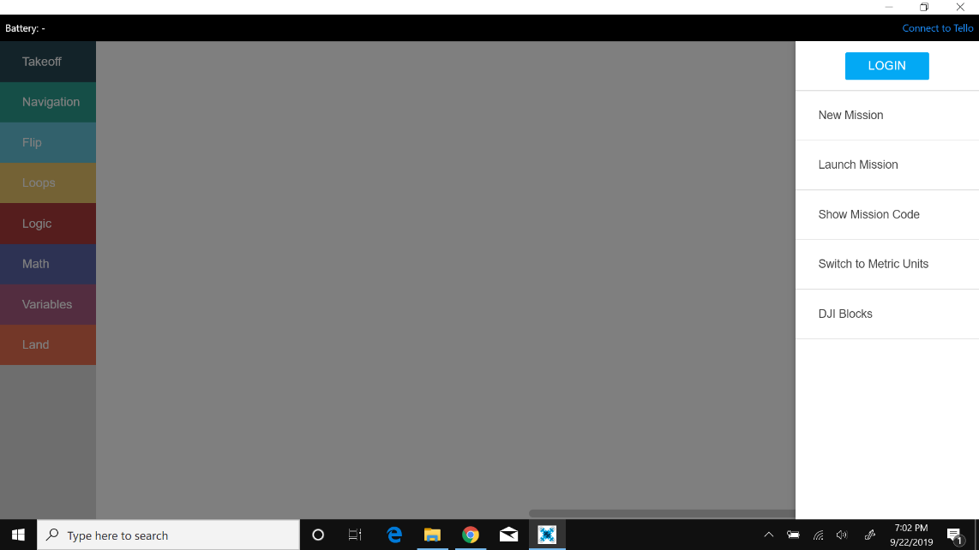

**Steps to get started with DroneBlocks:**

1. Launch DroneBlocks Application.
2. On the right side click on the three blue lines and press Login, this will ask you to login in with your Gmail account. Logging in will allow you to save missions.
3. Turn Tello Drone on and on your computer find the Tello’s Wi-Fi.
4. Connect to the Tello Wi-Fi.
5. Click on “Connect to Tello” on the right-hand side.
6. Click on connect button, you should see Tello’s batter percentage in the top left of DroneBlocks.
7. On the left side there is the command menu, get a takeoff block, hover block (found in Navigation) & land block and put them on the white canvas. Connect the blocks together to form a complete program.
8. Click on the three blue lines to get the side menu and find Launch mission. You can save the code by clicking on Save Mission or Save Mission as and name the mission.
9. Click on Launch mission to see your code in action.
10. Try out other blocks on the canvas and connect them together to see what Tello can do
11. To view saved missions just click on My Missions
12. You can switch between Standard and Metric Units

` DroneBlocks has an easy to use interface with all the basic commands for your

drone on the left-hand side in which you click on the command and it opens a

submenu of various commands to choose from as seen Figure 3. The basic

commands can have a variety of options to choose from and all you need to do is

drag the command onto the white canvas in the center like in Figure 4. Looking at

the commands in the center, you can see that they are shaped like a puzzle piece

and once you have two or more all you need to do is connect those puzzle pieces

together as shown on Figure 5. This allows you to create your own custom flight

codes quickly that you can save as “missions” as shown on Figure 6. To save code

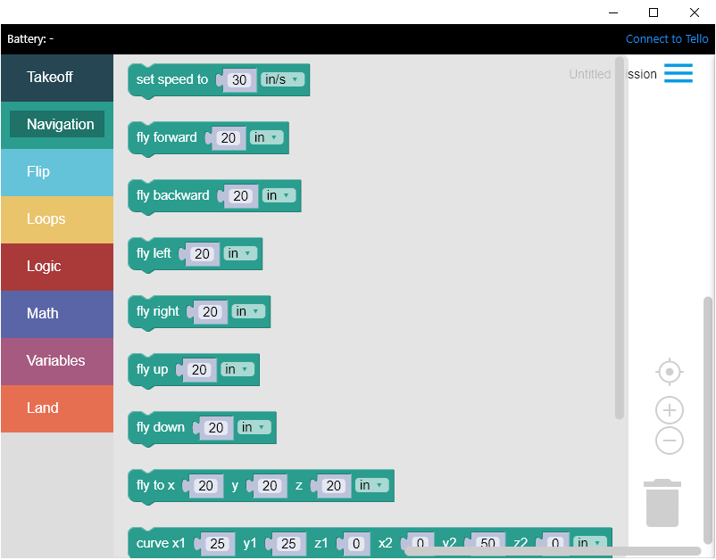

Figure 3: Example of “Navigation” submenu.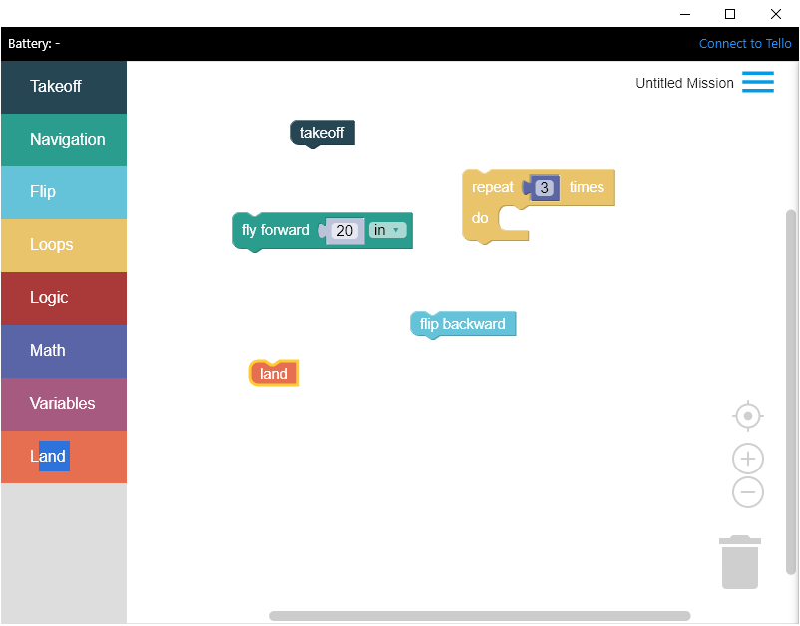

Figure 4: Commands on the canvas unassembled.

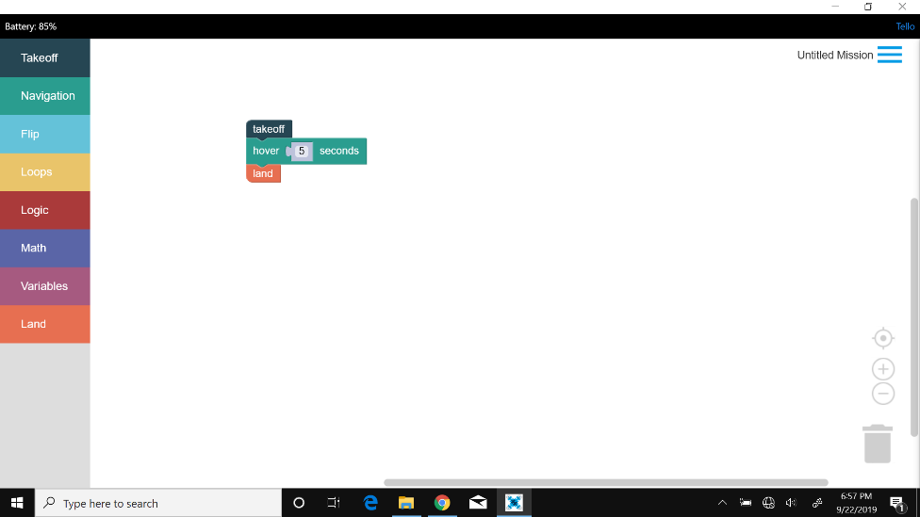

Figure 5: Assembled flight code with pieces connected.

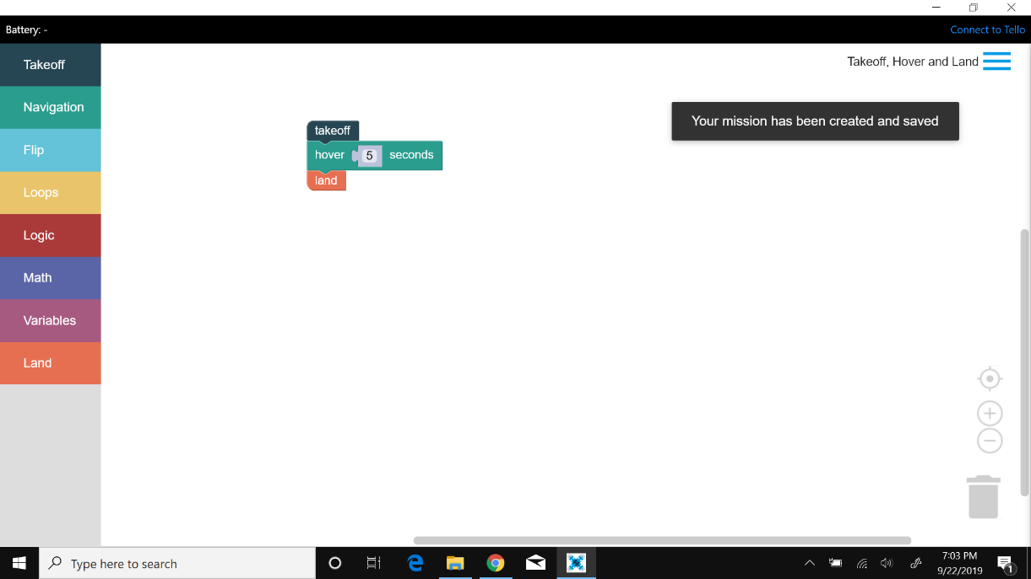

Figure 6: Mission Saved as: Takeoff, Hover and Land.

DroneBlocks works by using the Tello SDK and making use of the prebuilt functions already in the SDK. In Figure 7, you can see commands from the Tello SDK with an option that DroneBlocks provides that allows you to see the original code. In addition, another helpful feature that DroneBlocks provides is the ability to see the battery percentage of a connected drone as shown on Figure 8. This feature proves to be extremely helpful when testing flight codes because battery life affects certain actions. Figure 9 is a program for Box Drill for Tello.

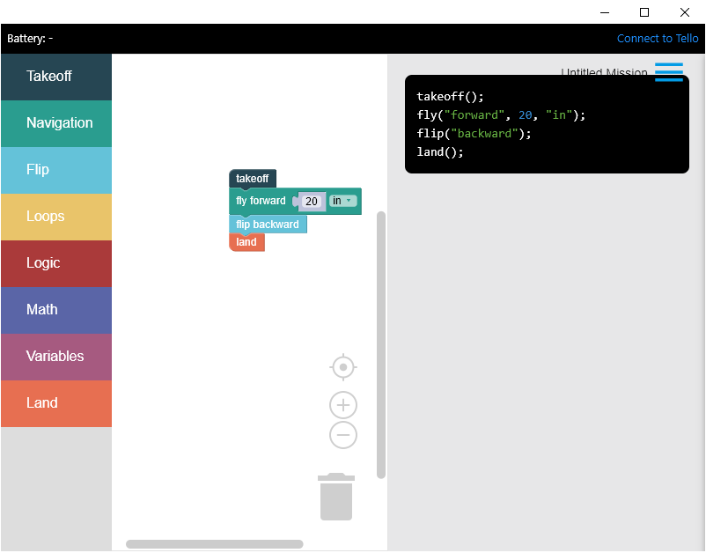

Figure 7: DroneBlocks allows you to see original code.

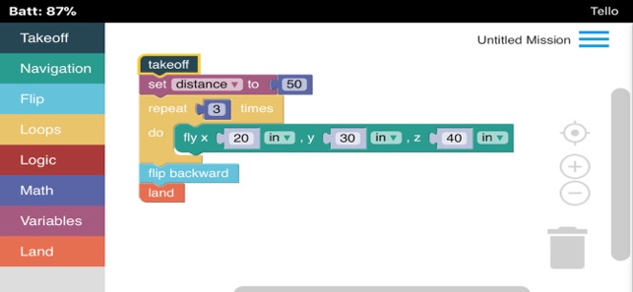

Figure 8: Droneblocks shows battery percentage of connected drone.

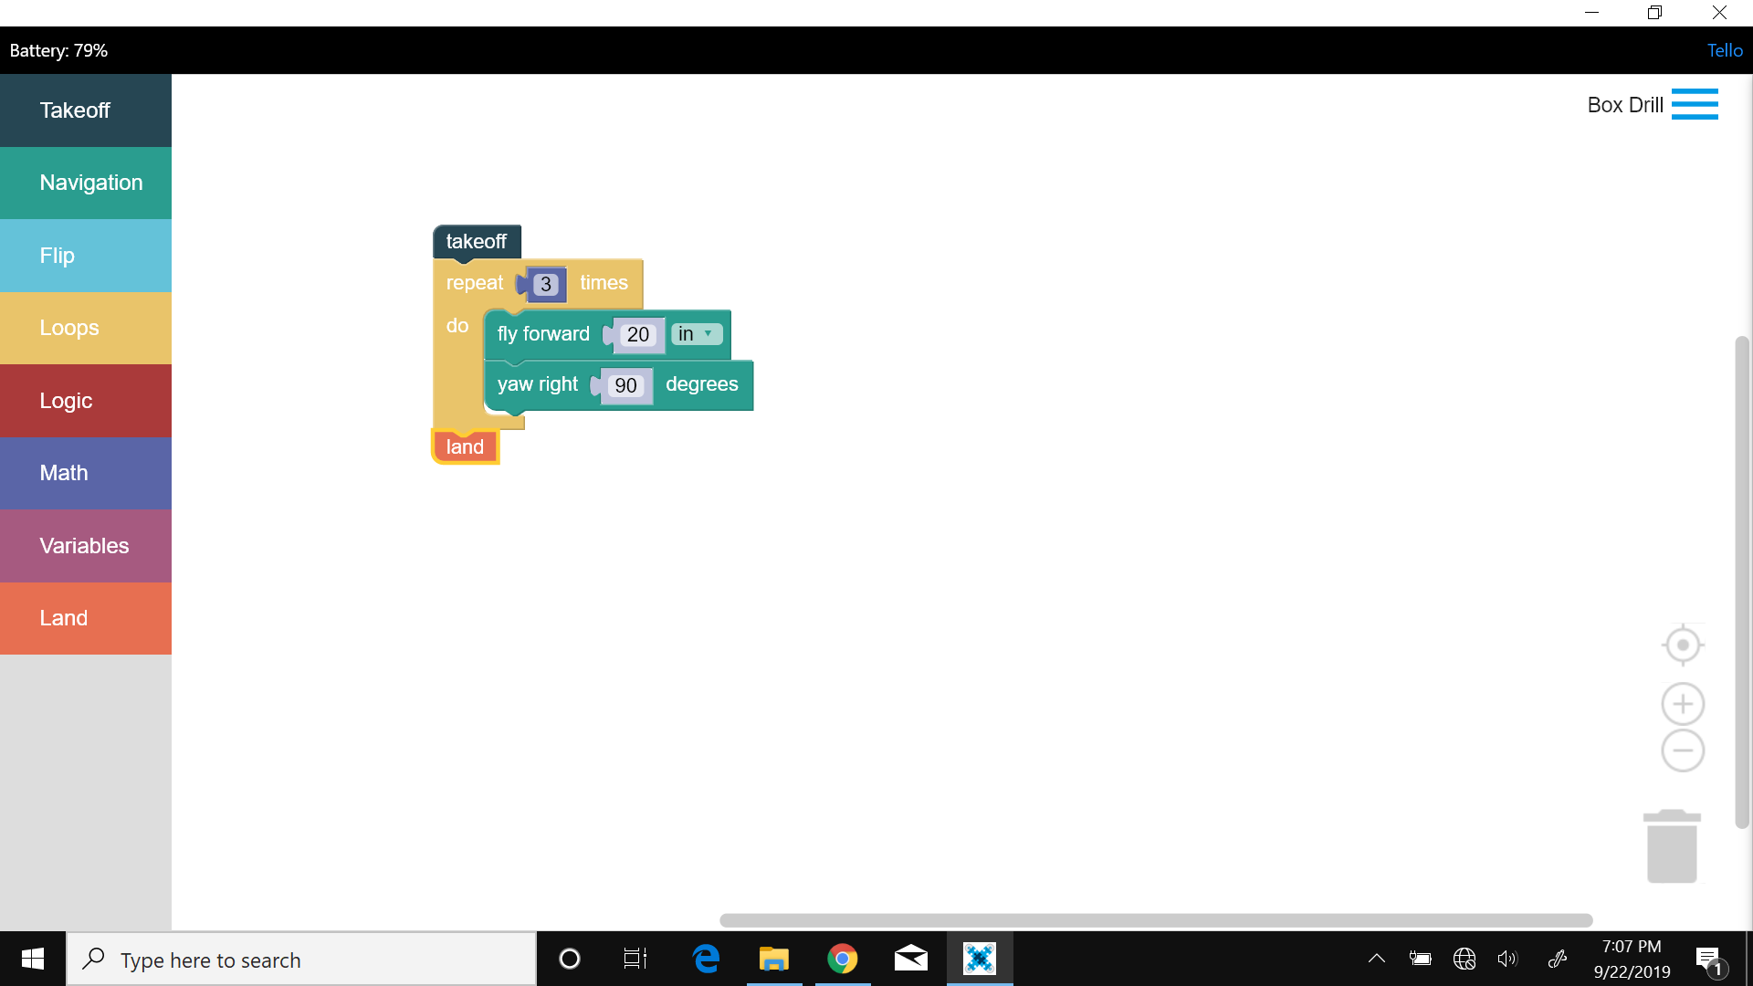

Figure 9: Box Drill

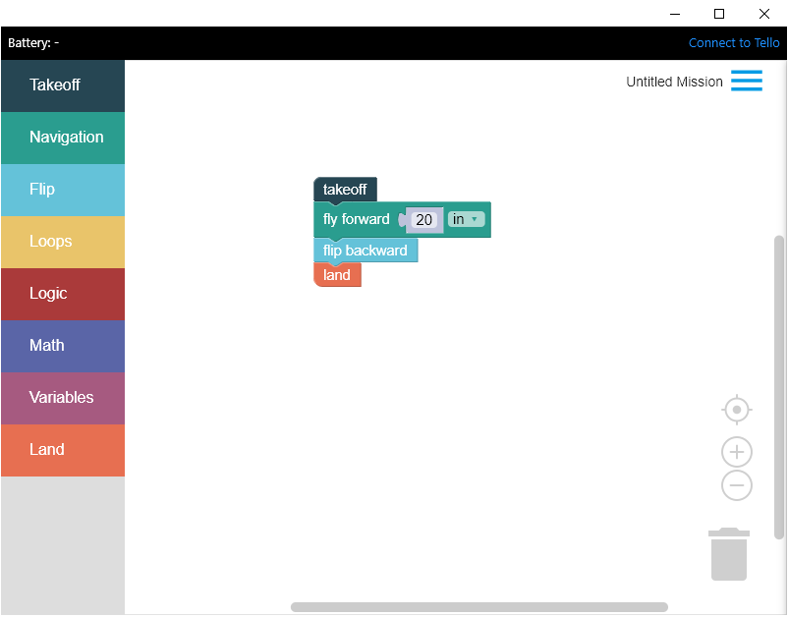**Commands available in DroneBlocks:**

* Takeoff
* Navigation

1. set speed to 30 in/s
2. fly forward 20 in
3. fly backward 20 in
4. fly left 20 in
5. fly right 20 in
6. fly up 20 in
7. fly down 20 in
8. fly certain distances(x,y,z) in
9. curve(x1,y1,z1,x2,y2,z2) in
10. hover 5 seconds
11. yaw right 90 degrees
12. yay left 90 degrees

* Flip

1. flip forward
2. flip backward
3. flip left
4. flip right

* Loops

-repeat certain # of times

* Logic

1. if blocks
2. comparison operators, and, or

* Math
  1. Number block
  2. Operator block
  3. Check number block
  4. Calculation block
  5. Trig Block
  6. Symbols block
* Variables
* Land
  1. land for 5 seconds and then takeoff bloc
  2. land

The “Introduction to Tello EDU Drone Programming with DroneBlocks” course covers the very basics of connecting the Tello to DroneBlocks and the basic commands that can be used to program the Tello and see it in action. The “DroneBlocks Introductory Course” is a course that starts to cover “Missions” in which the user programs the Tello to do a specific task utilizing loops to shorten and clean code. The “Introduction to Tello Drone Programming” course starts to cover more into depth with loops, variables, logic and if/else statements. The “Advanced Tello Programming with DroneBlocks” course covers how to use the Math command and its sub menu to do more complex movements like moving in a curve or calculating a specific spot to land. The “DroneBlocks Challenge Missions” course covers more advanced missions the user can attempt to see their mastery over DroneBlocks.

The free [DroneBlocks](https://learn.droneblocks.io/) courses offered gives the user easy to follow articles that teach the capabilities of DroneBlocks and what the user can do with DroneBlocks. The articles cover various topics, but each article focuses on specific topics like safety, connecting with DroneBlocks, how to make a complete program, etc. In addition, some articles do come with supplementary videos. The supplementary videos are used to show how to drag and drop the blocks to make a complete program.

**DroneBlocks Issues:**

1. Once drone initiates takeoff command it will only execute next command once it has stabilized.
2. There is a small delay between commands
3. Timers will only start after drone stabilizes which makes the seem to be inaccurate.
4. Flip commands only execute when drone is stabilized and above a certain battery percentage.
5. Sometimes the drone experiences signal loss in which case it skips any remaining commands and just lands the drone.
6. If drone is left idle for around 45 seconds to a 1 minute the drone will automatically turn off and lose connection with DroneBlocks
7. Once the drone gets around 10% battery it will start to be very slow to respond to commands.